Vadodara Institute of Engineering,
Kotambi
Start-up details of the students
Student Name  Branch  Pass-out Year  Mobile Number | Student Photo | Start-up detail | Company Photo
- Nikunj Vaghasiya | 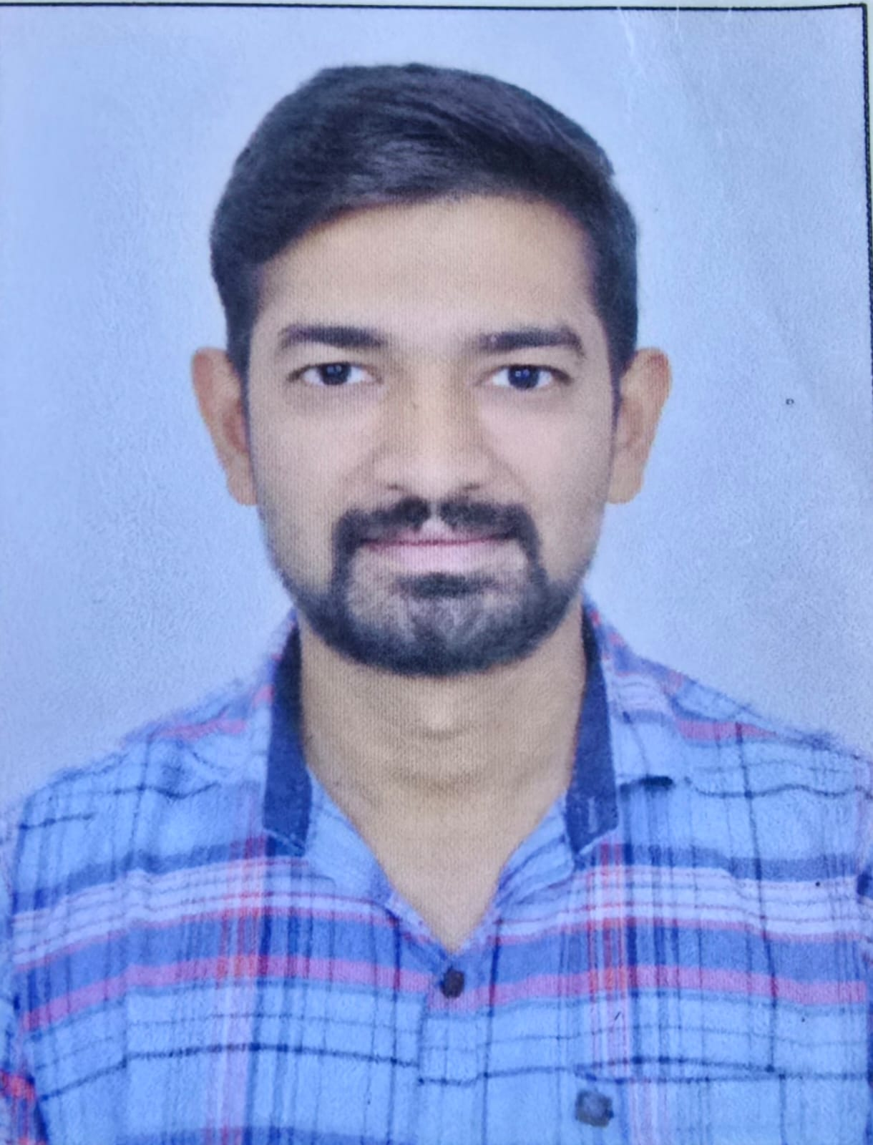   | NexTech Innovation start-up has been providing Panel Designing, Industrial Automation, Programmable Control Cards, Electrical Panel Manufacturing, Onsite Technical Maintenance Services | 
Electrical Engineering
2016 Passout
7405507537
- Meet Patel
Computer Engineering
2016 Passout
9408350999
Vadodara Institute of Engineering
Kotambi
Start-up details of the students
Student Name  Branch  Pass-out Year  Mobile Number | Student Photo | Start-up detail | Company Photo
- Nikunj Vaghasiya |  | Tech Master Engineers Pvt. Ltd. is involved in Manufacturing of Fully Automatic Envelope & Carton Window Pasting, making, Gumming, Folding, & Perforating Machines. | 
Electrical Engineering
2016 Passout
7405507537
- Jatin Patel
Information Technology
2016 Passout
7383497314

