Paper Format for National Conference “NC³R”

First A. Author¹, Second B. Author², and Third C. Author³
¹Name of Department, Institution, City, Country
Email: first.author@hostname1.org
²Name of Department, Institution, City, Country
Email: second. author@hostname2.org
³Name of Department, Institution, City, Country
Email: third. author@hostname3.org

Abstract—These instructions give you guidelines for preparing papers for NC³R.Use this document as a template if you are using Microsoft Word 6.0 or later. Otherwise, use this document as an instruction set. The electronic file of your paper will be formatted further at NC³R. Paper titles should be written in uppercase and lowercase letters, not all uppercase. Avoid writing long formulas with subscripts in the title; short formulas that identify the elements are fine (e.g., "Nd–Fe–B"). Do not write “(Invited)” in the title. Full names of authors are preferred in the author field, but are not required. Put a space between authors’ initials. Define all symbols used in the abstract. Do not cite references in the abstract. Do not delete the blank line immediately above the abstract; it sets the footnote at the bottom of this column.

Keywords—Enter key words or phrases in alphabetical order, separated by commas.

INTRODUCTION
T
HIS document is a template for Microsoft Word versions 6.0 or later

The style will adjust your fonts and line spacing. Do not change the font sizes or line spacing to squeeze more text into a limited number of pages. Use italics for emphasis; do not underline.

Procedure for Paper Submission

Review Stage
Submit your manuscript electronically for review.

Final Stage
When you submit your final version, after your paper has been accepted, prepare it in two-column format, including figures and tables.

Figures
As said, to insert images in Word, position the cursor at the insertion point and either use Insert | Picture | From File or copy the image to the Windows clipboard and then Edit | Paste Special | Picture (with “Float over text” unchecked).
The authors of the accepted manuscripts will be given a copyright form and the form should accompany your final submission.

MATH
If you are using Word, use either the Microsoft Equation Editor or the MathType add-on (http://www.mathtype.com) for equations in your paper (Insert | Object | Create New | Microsoft Equation orMathType Equation). “Float over text” should not be selected.

Equations
Number equations consecutively with equation numbers in parentheses flush with the right margin, as in (1). First use the equation editor to create the equation. Then select the “Equation” markup style. Press the tab key and write the equation number in parentheses. To make your equations more compact, you may use the solidus ( / ), the exp function, or appropriate exponents. Use parentheses to avoid ambiguities in denominators. Punctuate equations when they are part of a sentence, as in

(1)

Be sure that the symbols in your equation have been defined before the equation appears or immediately following. Italicize symbols (T might refer to temperature, but T is the unit tesla). Refer to “(1),” not “Eq. (1)” or “equation (1),” except at the beginning of a sentence: “Equation (1) is ... .”

Units
Use either SI (MKS) or CGS as primary units. (SI units are strongly encouraged.) English units may be used as secondary units (in parentheses). This applies to papers in data storage. For example, write “15 Gb/cm² (100 Gb/in²).” An exception is when English units are used as identifiers in trade, such as “3½-in disk drive.” Avoid combining SI and CGS units, such as current in amperes and magnetic field in oersteds. This often leads to confusion because equations do not balance dimensionally. If you must use mixed units, clearly state the units for each quantity in an equation.
The SI unit for magnetic field strength H is A/m. However, if you wish to use units of T, either refer to magnetic flux density B or magnetic field strength symbolized as µ₀H. Use the center dot to separate compound units, e.g., “A·m².”
TABLE I
Units for Magnetic Properties
Symbol | Quantity | Conversion from Gaussian and  CGS EMU to SI ª
Φ | magnetic flux | 1 Mx→ 10⁻⁸Wb = 10⁻⁸ V·s
B | magnetic flux density,  magnetic induction | 1 G → 10⁻⁴ T = 10⁻⁴Wb/m²
H | magnetic field strength | 1 Oe→ 10³/(4π) A/m
m | magnetic moment | 1 erg/G = 1 emu  → 10⁻³ A·m² = 10⁻³ J/T
M | magnetization | 1 erg/(G·cm³) = 1 emu/cm³  → 10³ A/m
4πM | magnetization | 1 G → 10³/(4π) A/m
σ | specific magnetization | 1 erg/(G·g) = 1 emu/g → 1 A·m²/kg
j | magnetic dipole  moment | 1 erg/G = 1 emu  → 4π× 10⁻¹⁰Wb·m
J | magnetic polarization | 1 erg/(G·cm³) = 1 emu/cm³  → 4π× 10⁻⁴ T
χ,κ | susceptibility | 1 → 4π
χ_{ρ} | mass susceptibility | 1 cm³/g → 4π× 10⁻³ m³/kg
μ | permeability | 1 → 4π× 10⁻⁷ H/m  = 4π× 10⁻⁷Wb/(A·m)
μ_{r} | relative permeability | μ→μ_{r}
w, W | energy density | 1 erg/cm³→ 10⁻¹ J/m³
N, D | demagnetizing factor | 1 → 1/(4π)
Vertical lines are optional in tables. Statements that serve as captions for the entire table do not need footnote letters.
ªGaussian units are the same as cg emu for magnetostatics; Mx = maxwell, G = gauss, Oe = oersted; Wb = weber, V = volt, s = second, T = tesla, m = meter, A = ampere, J = joule, kg = kilogram, H = henry.

Some Common Mistakes
The word “data” is plural, not singular. The subscript for the permeability of vacuum µ₀ is zero, not a lowercase letter “o.” The term for residual magnetization is “remanence”; the adjective is “remanent”; do not write “remnance” or “remnant.” Use the word “micrometer” instead of “micron.” A graph within a graph is an “inset,” not an “insert.” The word “alternatively” is preferred to the word “alternately” (unless you really mean something that alternates). Use the word “whereas” instead of “while” (unless you are referring to simultaneous events). Do not use the word “essentially” to mean “approximately” or “effectively.” Do not use the word “issue” as a euphemism for “problem.” When compositions are not specified, separate chemical symbols by en-dashes; for example, “NiMn” indicates the intermetallic compound Ni_{0.5}Mn_{0.5} whereas “Ni–Mn” indicates an alloy of some composition Ni_{x}Mn_{1-x}.
Be aware of the different meanings of the homophones “affect” (usually a verb) and “effect” (usually a noun), “complement” and “compliment,” “discreet” and “discrete,” “principal” (e.g., “principal investigator”) and “principle” (e.g., “principle of measurement”). Do not confuse “imply” and “infer.”
Prefixes such as “non,” “sub,” “micro,” “multi,” and “ultra” are not independent words; they should be joined to the words they modify, usually without a hyphen. There is no period after the “et” in the Latin abbreviation “et al.” (it is also italicized). The abbreviation “i.e.,” means “that is,” and the abbreviation “e.g.,” means “for example” (these abbreviations are not italicized).
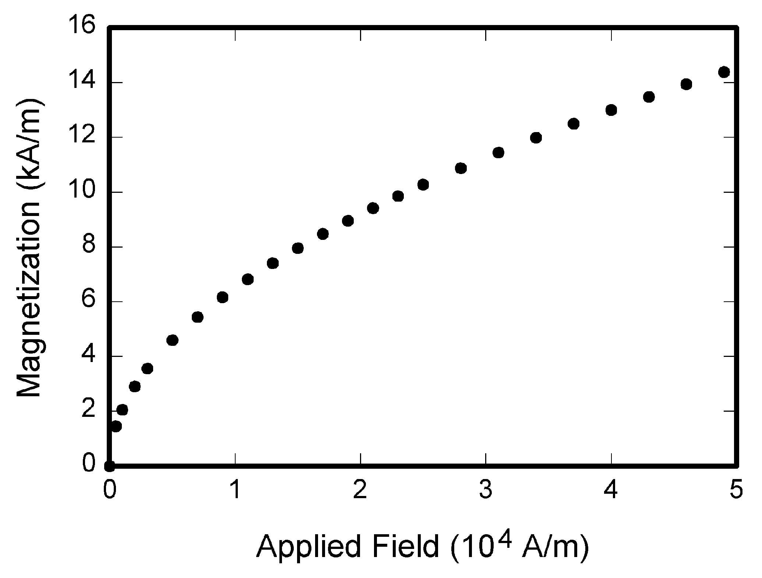
Fig. 1.Magnetization as a function of applied field. Note that “Fig.” is abbreviated. There is a period after the figure number, followed by two spaces. It is good practice to explain the significance of the figure in the caption.

Guidelines for Graphics Preparation
and Submission

Types of Graphics
The following list outlines the different types of graphics published in IEEE journals. They are categorized based on their construction, and use of color / shades of gray:

Color/Grayscale figures

Figures that are meant to appear in color, or shades of black/gray. Such figures may include photographs,
illustrations, multicolor graphs, and flowcharts.

Lineart figures

Figures that are composed of only black lines and shapes. These figures should have no shades or half-tones of gray. Only black and white.

Author photos

Head and shoulders shots of authors which appear at the end of our papers.

Tables
Data charts which are typically black and white, but sometimes include color.

Multipart figures
Figures compiled of more than one sub-figure presented side-by-side, or stacked. If a multipart figure is made up of multiple figure types (one part is lineart, and another is grayscale or color) the figure should meet the stricter guidelines.

File Formats For Graphics
Format and save your graphics using a suitable graphics processing program that will allow you to create the images as PostScript (PS), Encapsulated PostScript (.EPS), Tagged Image File Format (.TIFF), Portable Document Format (.PDF), or Portable Network Graphics (.PNG) sizes them, and adjusts the resolution settings. If you created your source files in one of the following programs you will be able to submit the graphics without converting to a PS, EPS, TIFF, PDF, or PNG file: Microsoft Word, Microsoft PowerPoint, or Microsoft Excel. Though it is not required, it is recommended that these files be saved in PDF format rather than DOC, XLS, or PPT. Doing so will protect your figures from common font and arrow stroke issues that occur when working on the files across multiple platforms. When submitting your final paper, your graphics should all be submitted individually in one of these formats along with the manuscript.

Sizing of Graphics
Most charts, graphs, and tables are one column wide (3.5 inches / 88 millimeters / 21 picas) or page wide (7.16 inches / 181 millimeters / 43 picas). The maximum depth a graphic can be is 8.5 inches (216 millimeters / 54 picas). When choosing the depth of a graphic, please allow space for a caption. Figures can be sized between column and page widths if the author chooses, however it is recommended that figures are not sized less than column width unless when necessary.

Accepted Fonts Within Figures
When preparing your graphics IEEE suggests that you use of one of the following Open Type fonts: Times New Roman, Helvetica, Arial, Cambria, and Symbol. If you are supplying EPS, PS, or PDF files all fonts must be embedded. Some fonts may only be native to your operating system; without the fonts embedded, parts of the graphic may be distorted or missing.
A safe option when finalizing your figures is to strip out the fonts before you save the files, creating “outline” type. This converts fonts to artwork what will appear uniformly on any screen.

Referencing a Figure or Table Within Your Paper
When referencing your figures and tables within your paper, use the abbreviation “Fig.” even at the beginning of a sentence. Do not abbreviate “Table.” Tables should be numbered with Roman Numerals.

Conclusion

A conclusion section is not required. Although a conclusion may review the main points of the paper, do not replicate the abstract as the conclusion. A conclusion might elaborate on the importance of the work or suggest applications and extensions.

Appendix
Appendixes, if needed, appear before the acknowledgment.

Acknowledgment
The preferred spelling of the word “acknowledgment” in American English is without an “e” after the “g.” Use the singular heading even if you have many acknowledgments. Avoid expressions such as “One of us (S.B.A.) would like to thank ... .” Instead, write “F. A. Author thanks ... .”In most cases, sponsor and financial support acknowledgments are placed in the unnumbered footnote on the first page, not here.

References
Basic format for books:
- J. K. Author, “Title of chapter in the book,” in Title of His Published Book, xth ed. City of Publisher, Country if not
- USA: Abbrev. of Publisher, year, ch.x, sec. x, pp. xxx–xxx.
Examples:
- G.O.Young,“Syntheticstructureofindustrial plastics,”in Plastics, 2nded., vol. 3, J. Peters, Ed. New York: McGraw-Hill,1964,pp.15–64.
- W.-K.Chen,LinearNetworksandSystems.Belmont, CA:Wadsworth, 1993, pp. 123–135.

Basic format for periodicals:
- J. K. Author, “Name of paper,” Abbrev. Title of Periodical, vol. x, no. x, pp. xxx-xxx, Abbrev. Month, year.
Examples:
- J. U. Duncombe, “Infrared navigation—Part I: An assessment
of feasibility,” IEEE Trans. Electron Devices, vol. ED-11, no. 1, pp. 34–39, Jan. 1959.
- E. P. Wigner, “Theory of traveling-wave optical laser,”Phys. Rev.,
vol. 134, pp. A635–A646, Dec. 1965.
- E. H. Miller, “A note on reflector arrays,” IEEE Trans.Antennas Propagat., to be published.

Basic format for conference proceedings (published):
- J. K. Author, “Title of paper,” in Abbreviated Name of Conf., City of Conf., Abbrev. State (if given), year, pp. xxxxxx.
Example:
- D. B. Payne and J. R. Stern, “Wavelength-switched pas- sivelycoupledsingle-mode opticalnetwork,”in Proc. IOOC-ECOC,1985,
pp.585–590.
Basic formatfor theses (M.S.) and dissertations (Ph.D.):
- J. K. Author, “Title of thesis,” M.S. thesis, Abbrev. Dept., Abbrev. Univ., City of Univ., Abbrev. State, year.
- J. K. Author, “Title of dissertation,” Ph.D. dissertation, Abbrev. Dept., Abbrev. Univ., City of Univ., Abbrev. State,year.
Examples:
- J. O. Williams, “Narrow-band analyzer,” Ph.D. dissertation, Dept. Elect. Eng., Harvard Univ., Cambridge, MA,1993.

